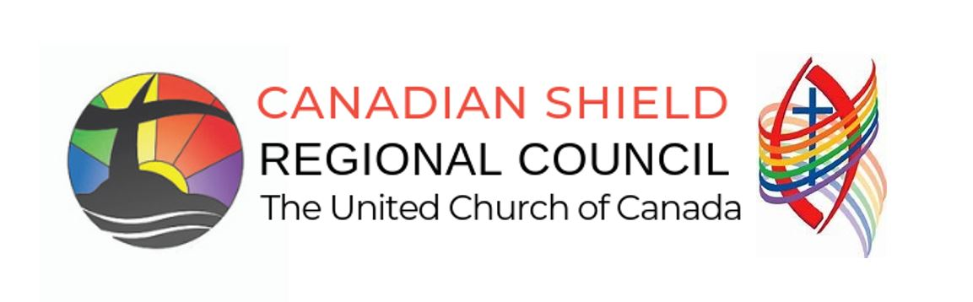

Creating a Proposal to be consider by the General Council or Regional Council:

Proposals can be created to be considered by the Regional Council or the Regional Council Executive. A “proposal” is a formal request for the council to take action. It is one way that a United Church member may raise an issue that is important to them and ask for the church to take action on it.

The 2026 Manual, Section F.1, describes in detail how a proposal may be submitted. The outline below also provides a template for creating a proposal. Proposals can be submitted before the Regional Council Meeting, to be circulated in the regional meeting Workbook or, a proposal can be submitted to the Business and Agenda Committee before the scheduled close of submission of new business during our Regional Council Meeting. See the CSRC Meeting Agenda for specific close of business time.

Proposal [template] (also see 2026 Manual, Section F.1)

PROPOSAL NAME
Origin: [Regional Council Name]

- What is the issue? Why is it important?
Briefly describe (approximately four sentences) the issue and its significance.

Sample wording:
We believe God/Jesus/The Holy Spirit is calling us to:
- do something about…
- engage the topic of…
- respond to the challenge of…

- What is happening now?
Provide a description of the current practice or policy in question, identifying/citing the source of this information.

- What is the recommendation?
Describe how the General Council might respond to the issue.
To avoid being overly prescriptive, please offer multiple options of how the General Council might respond. Commentary may be offered on the projected outcome of adopting each option.

Sample Wording:
(Name) proposes that the General Council could:

- Study/discuss the issue:
The General Council could be asked to have a conversation about a particular issue as an end in itself without making a policy decision or taking other action.

- Act on the issue, which could include:
- General Council directing a policy/strategy be developed based on specified principles and parameters
- General Council adopting a policy position/strategy
- General Council encouraging/suggesting action by congregations and other communities of faith on the issue
Suggestions for wording of a policy/strategy could be offered as possibilities for consideration in the decision-making process but not as expectations of a particular outcome.
4. Background information:
Provide details the General Council needs to make an informed decision on the proposal.

What is the history of this issue? What are key underlying theological, ecclesiological, missional, or justice considerations? What are the principles informing this issue?

5. How does this proposal help us to live into our church’s commitments on equity?
Describe in broad terms how this proposal engages with the United Church’s established principles and positions on equity.

Over the course of several years, General Council has made numerous commitments on equity such as the following:
- adopting the United Nations Declaration on the Rights of Indigenous Peoples as the framework for reconciliation between Indigenous and non-Indigenous peoples;
- adopting the Calls to the Church from the Caretakers of our Indigenous Circle as the basis for a new relationship;
- welcoming people of all sexual orientations and gender identities into full membership and ministry in the church;
- committing to becoming an intercultural church;
- committing to becoming an open, accessible, and barrier-free church, where there is full participation of people with disabilities;
- working towards functional bilingualism and ensuring that Francophone ministries are an integral part of the church’s identity, mission, and vision;
- opposing discrimination of any kind on the basis of identity; and,
- developing an anti-racism policy and committing to becoming an anti-racist denomination.

Who has been consulted in the development of the proposal? Was the proposal developed “with” people, or “on behalf of” people? What might be the impact of this proposal on people and communities? Who is advantaged and who is disadvantaged by this approach?

