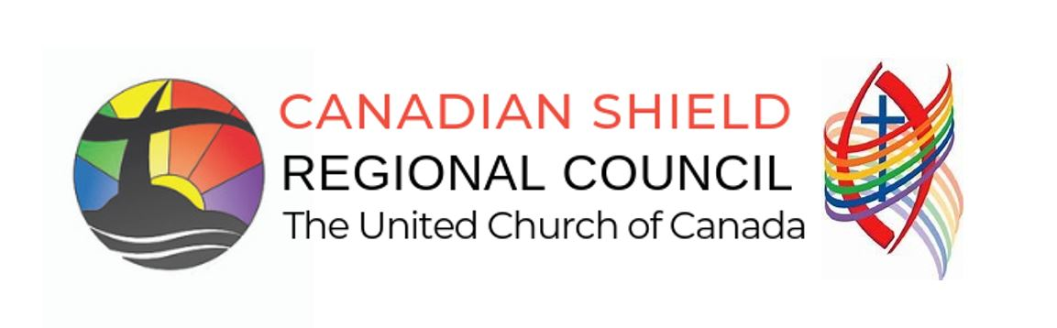

Creating a Proposal to be consider by the General Council or Regional Council:

Proposals can be created to be considered by the Regional Council or the Regional Council Executive. A “proposal” is a formal request for the council to take action. It is one way that a United Church member may raise an issue that is important to them and ask for the church to take action on it.

The 2025 Manual, Section F.1, describes in detail how a proposal may be submitted. The outline below also provides a template for creating a proposal. Proposals can be submitted before the Regional Council Meeting, to be circulated in the regional meeting Workbook or, a proposal can be submitted to the Business and Agenda Committee before the scheduled close of submission of new business during our Regional Council Meeting. See the CSRC Meeting Agenda for specific close of business time.

Proposal [template] (also see 2025 Manual, Section F.1)

PROPOSAL NAME
Origin: [Regional Council Name]

- What is the issue? (describe in broad terms)

We believe God/Jesus/Holy Spirit is calling us to:
- do something about…
- engage the topic of…
- respond to the challenge of…
- etc.

Note: Proposals for the General Council are for issues of denominational responsibility that go beyond the bounds of a Regional Council.

Proposals for the Regional Council are for issues of Regional Council responsibility that are within the bounds of the Regional Council.

Proposals can also be created for consideration, to be forwarded to the General Council by the Regional Council (see Section F of the 2021 Manual, Section F, Initiating Action and Change)

- Why is this issue important?
For example:
- What are the key underlying theological, ecclesiological, missional, or justice issues?
- What is the history/background of this issue?
- What are the principles informing this issue?
- What would be the implications of taking no action on this issue?

- How does this proposal help us to live into our church’s commitments on equity?
Over the course of several years, General Council has made the following commitments on equity. Describe in broad terms the ways in which this proposal engages with some of these principles:
- adopting the United Nations Declaration on the Rights of Indigenous Peoples as the framework for reconciliation between Indigenous and non-Indigenous peoples;
- adopting the Calls to the Church from the Caretakers of our Indigenous Circle as the basis for a new relationship;
- welcoming people of all sexual orientations and gender identities into full membership and ministry in the church;
- committing to becoming an intercultural church;
- committing to becoming an open, accessible, and barrier-free church, where there is full participation of people with disabilities;
- working towards functional bilingualism and ensuring that Francophone ministries are an integral part of the church’s identity, mission, and vision;
- opposing discrimination of any kind on the basis of identity; and
- developing an anti-racism policy and committing to becoming an anti-racist denomination.

Who has been consulted in the development of the proposal? Was the proposal developed “with” people, or “on behalf of” people? What might be the impact of this proposal on people and communities? Who is advantaged and who is disadvantaged by this approach?

- How might the General Council/Regional Council respond to the issue?

The (regional council) proposes that the General Council could:

Name a possible response that the General Council/Regional Council might consider:

- Study/discussion of the issue

- Action on the issue, which could include
- General Council/Regional Council directing that a policy/strategy be developed based on
specified principles and parameters;
- General Council/Regional Council adopting a policy position/strategy;
- General Council/Regional Council encouraging/suggesting action by congregations and other
communities of faith on the issue.
Note to 3.A: The General Council/Regional Council could be asked to have a conversation about a particular issue as an end in itself without making a policy decision or taking other action.
Note to 3.B: Suggestions for wording of a policy/strategy could be offered as possibilities for consideration in the decision-making process but not as expectations of a particular outcome.

- For the body transmitting this proposal to the General Council:
Are there comments, affirmations, suggestions you would like to make with respect to this proposal? Is this proposal in response to a previous proposal, motion or action? If so, please name the previous action(s) and proposal number(s).

