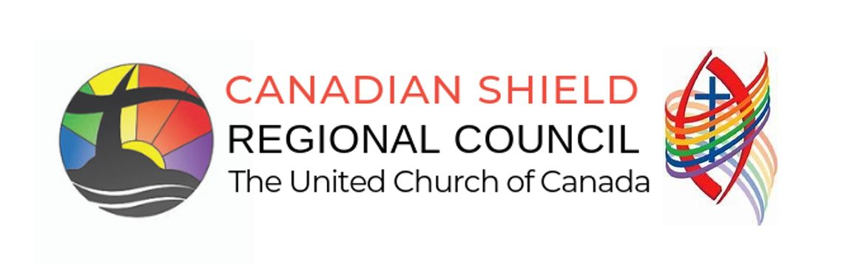
Community of Faith: Living Faith Story Worksheet

PURPOSE: To provide information about the Community of Faith’s understanding of their ministry and mission.
Who uses it: Communities of Faith in regularly assessing their ministry and in gathering their profile information for ChurchHub.
Community of Faith:
Address:
Pastoral Charge:
Regional Council:
Date:

- Mission Statement:
Click or tap here to enter text.
- Values:
Click or tap here to enter text.
- Summary of your community of faith:
Click or tap here to enter text.

- Definition of Current Ministry
(How would you describe your ministry; What is important to you in each category?)
  - Administration:
Click or tap here to describe your ministry in this category
  - Community Outreach & Social Justice:
Click or tap here to describe your ministry in this category
  - Continuing Education:
Click or tap here to describe your ministry in this category
  - Denomination & Communities:
Click or tap here to describe your ministry in this category
  - Faith Formation & Christian Education:
Click or tap here to describe your ministry in this category
  - Leadership:
Click or tap here to describe your ministry in this category
  - Pastoral Care:
Click or tap here to describe your ministry in this category
  - Self Care:
Click or tap here to describe your ministry in this category
  - Worship:
Click or tap here to describe your ministry in this category
- Do you have any goals for the next year that might enhance your current ministry or begin something new? ☐ No ☐ Yes If yes, please list or append.
Click or tap here to enter text.

