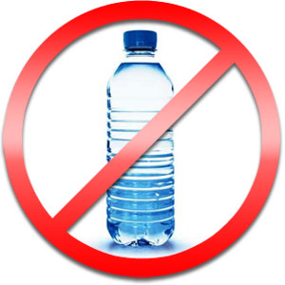

Chisholm United Church
prayerfully requests that single-use water bottles
not be used at our church.

Why?

- Bottled water leads to water shortages. Withdrawing water from underground aquifers drains natural water reserves.

- Bottled water contributes to climate change. The bottled water industry requires massive amounts of fossil fuels to manufacture and transport their products.

- Our landfill sites cannot handle the volume of garbage that is created by empty water bottles. Canadian municipalities are dealing with a waste management crisis. In some communities the percentage of water bottles that end up in landfills can be as high as 80 per cent.

- Bottled water is not safer. Companies advertise their products as a “safer and healthier alternative.” Water bottling plants are inspected on average once every three years but municipal tap water is tested continuously – both during and after treatment.

- Water is a human right. Water is a human right and should be guaranteed to all people regardless of their ability to pay. No one should be able to control it or expropriate it for profit. The bottled water industry has worked hard to undermine our faith in public water. Canada has one of the best public drinking water systems in the world.

So join us, in caring for God’s Creation—and the gift of water we have been given
to share, a gift that sustains all life.

Information on this poster has been taken from www.canadians.org/bluecommunities &
www.united-church.ca see “Water: Life before Profit”

