Water is a human right.

Water should be guaranteed to all people regardless of their ability to pay and no matter where they live in the world.

Water is an essential and irreplaceable resource for people’s health and for our planet as a whole.

No individual, group or company should be able to control it or expropriate it for profit.

The bottled water industry has worked hard to undermine our faith in public water. Canada has one of the best public drinking systems in the world.

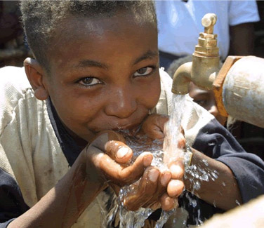

Instead of high-priced bottled water, we need a National Water Policy that would further improve the public water system, enshrine the human right to water in legislation, and ensure clean drinking water standards for all communities across the country.

