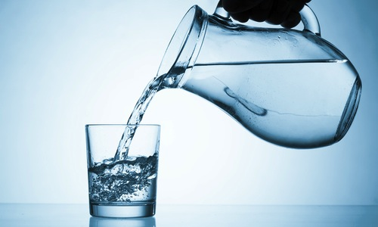

Bottled water is not safer.

In order to persuade people to spend 200 – 3,000 times what they spend on tap water, bottled water companies advertise their products as a “safer and healthier alternative.”

Water bottling plants are inspected on average only once every three years, according to the Polaris Institute, an Ottawa-based research organization.

Tap water regulation, on the other hand, is far more stringent. Municipal tap water is tested continuously—both during and after treatment. “Back the tap!”

