Our landfills cannot handle the volume of garbage that is created by empty water bottles.

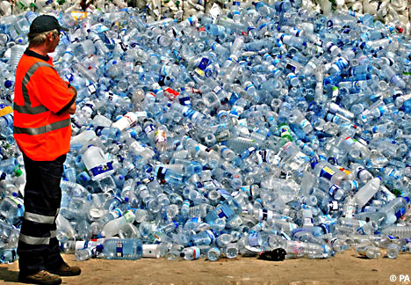

Canadian municipalities are dealing with a waste management crisis. In some large urban centres such as Toronto as few as 50% of water bottles are being recycled. In some communities the percentage of water bottles that end up in landfills can be as high as 80 per cent.

