Bottled water contributes to climate change.

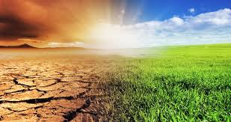

In an era when the world is dealing with the impacts of climate change, the bottled water industry requires massive amounts of fossil fuels to manufacture, refrigerate and transport their products.

For example, according to the Bow River Keeper, a citizen’s group that protects the Bow River watershed in Alberta, in order to produce ONE KILOGRAM OF FIJI WATER, it takes 26.88 kilograms of water, 0.849 kilograms of fossil fuel and there is a production of 562 grams of greenhouse gases.

