Bottled water leads to water shortages.

Withdrawing water from underground aquifers and springs, drains natural water reserves, placing whole watersheds under threat.
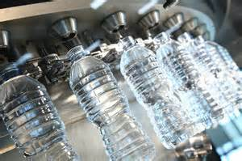

Manufacturing water bottles also requires huge amounts of water. It takes three to five litres of water to produce every one-litre plastic bottle.

